Experiment 3: Class A Amplifier

**Name:** Chiajui Lee

**Class:** Electronic 3B

**Student ID:** B11102112

Contents

I. Purpose 1

II. Materials Used 1

A. Resistors 1

B. Capacitors 1

C. Other Components 2

III. Principle 2

A. Linear Amplification 2

B. Static Bias Current 2

IV. Operating Points of Different Amplifier Types 2

A. Class A Operating Point 2

B. Class B Amplifier 3

C. Class AB Amplifier 3

V. Circuit Diagram 3

VI. Measurements 4

A. DC Test 4

B. AC Test 4

VII. Reflections 8

### Purpose

The main goal of this Class A amplifier experiment is to gain a deeper understanding of the operating mechanism of a Class A amplifier through practical circuit operation and measurements, and to verify its theoretical characteristics. In this experiment, we will measure important parameters such as voltage gain and current gain, and evaluate its performance in terms of efficiency, distortion, and other factors. Additionally, we will compare the experimental results with theoretical calculations to validate the accuracy of the theoretical model and understand the potential non-ideal factors in actual circuits. More importantly, by building and testing the Class A amplifier circuit, we will develop practical analysis and troubleshooting skills, and become familiar with the use of electronic measurement instruments such as oscilloscopes, signal generators, and multimeters. This will help us gain a deeper understanding of the applications of Class A amplifiers in fields such as audio amplification and signal processing.

### Materials Used

##### Resistors

47Ω*2, 51Ω*2, 470Ω*1, 1kΩ*2, 3.9kΩ*2, 33kΩ*2, 50kΩ*1, 100kΩ*4

##### Capacitors

330pF*2, 0.18µF*3, 0.68µF*2, 10µF*1, 33µFΩ*1, 100µF*2, 470µF*2, 1000µF*1

1. Types of Capacitors
2. Ceramic Capacitor

* Characteristics: Ceramic capacitors are small in size, low in cost, and offer relatively high stability. However, they are susceptible to temperature and voltage changes. Their capacitance is usually small and tends to change with frequency variations.
* Applications: Ceramic capacitors are commonly used in filtering, coupling, and decoupling circuits, especially in high-frequency applications. They are also used in oscillators and high-frequency signal processing.

1. Film Capacitor

* Characteristics: Film capacitors have better stability and low leakage current, and they typically offer a longer lifespan. They have higher voltage tolerance but are generally larger in size.
* Applications: Film capacitors are suitable for high-precision circuits, such as audio equipment, filtering circuits, and voltage regulation circuits, especially in high-frequency applications where they provide stable performance.

1. Electrolytic Capacitor

* Characteristics: Electrolytic capacitors have a large capacitance and relatively large size, with a clear polarity. Their internal structure gives them high capacitance characteristics, but this also results in a shorter lifespan and greater susceptibility to environmental factors.
* Applications: Electrolytic capacitors are commonly used in DC filtering circuits and power supply circuits to filter voltage and stabilize DC power. They are also frequently found in audio amplifiers and other low-frequency applications.

##### Other Components

LED*1 , 1N4001*4 , TL072*1, LM340*1, F2907*2

### Principle

##### Linear Amplification

* The core design of a Class A amplifier is to ensure that the amplifying component (usually a transistor) remains within the linear operating region throughout the entire input signal cycle. Regardless of how the input signal varies, the amplifying component can linearly amplify the signal, producing an output that is proportionally amplified relative to the input signal.
* This characteristic of linear amplification allows Class A amplifiers to provide very low distortion, ensuring that the output signal closely replicates the waveform of the input signal.

##### Static Bias Current

* To maintain the linear operation of the amplifying component, a Class A amplifier requires a relatively large static bias current.
* Since there is a continuous current flowing through the amplifying component even without an input signal, the efficiency of a Class A amplifier is relatively low.

### Operating Points of Different Amplifier Types

##### Class A Operating Point

* Advantages: High linearity, low distortion, and excellent sound quality.
* Disadvantages: Low efficiency (around 20-30%), high heat generation, and high power consumption.

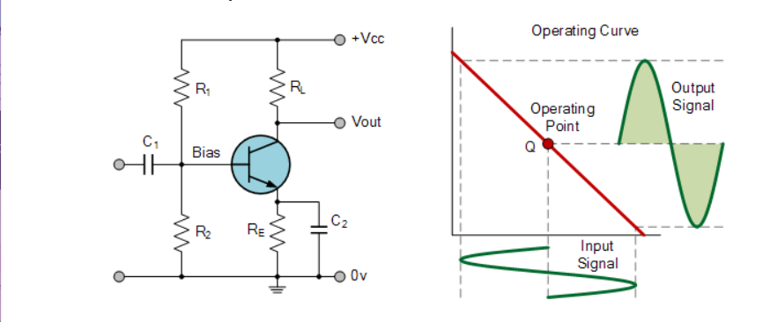

##### Class B Amplifier

* Advantages: High efficiency (around 70–80%), less heat generation, and lower power consumption.
* Disadvantages: Higher distortion, especially near the crossover point, resulting in slightly lower sound quality.

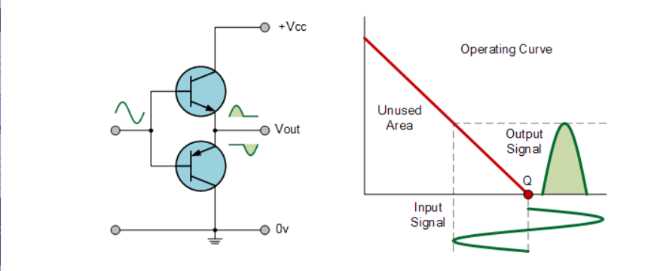

##### Class AB Amplifier

* Advantages: High efficiency (around 50–70%), lower distortion, and better sound quality.
* Disadvantages: Generates less heat than Class A amplifiers but slightly more than Class B amplifiers.

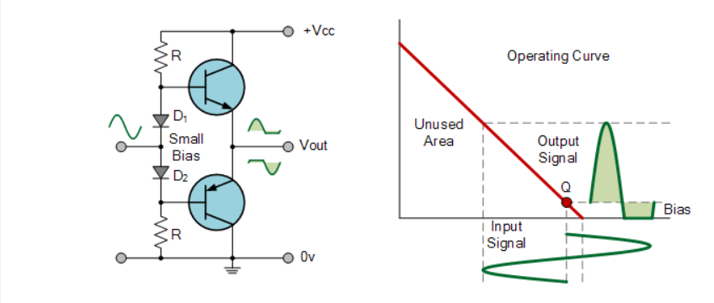

### Circuit Diagram

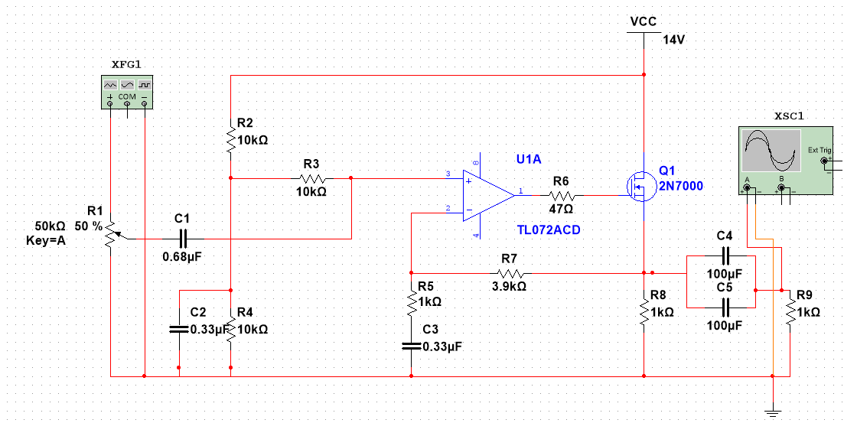

### Measurements

##### DC Test

|  |  |  |  |  |  |  |
| --- | --- | --- | --- | --- | --- | --- |
| TL072 pin8 | TL072 pin3 | TL072 pin5 | VR7 | VG | IQ | VCH2  ( VRmin ) |
| 12.84V | 6.73V | 6.73V | 5.96V | 9.83V | 0.117A | 0.84V |

##### AC Test

###### Adjust VR → Vp-p = 1V

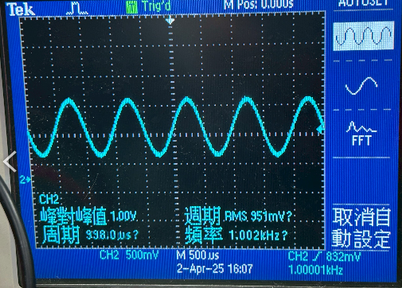

###### Calculate Voltage gain

###### Square Wave test

1. 100Hz input

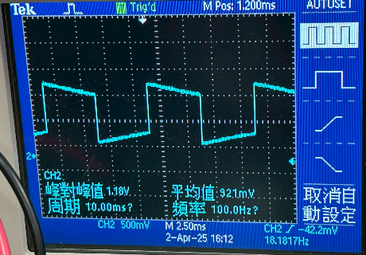

1. 1KHz input

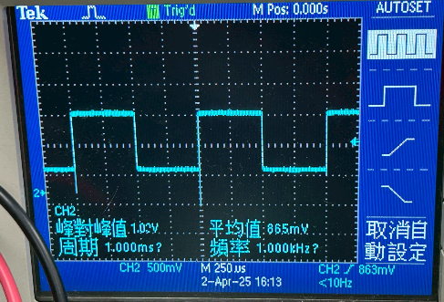

1. 10KHz input

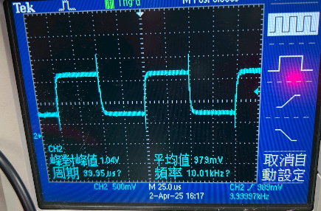

###### Find High and low-frequency cutoff points

1. High-frequency cutoff point, f‑c = 137kHz

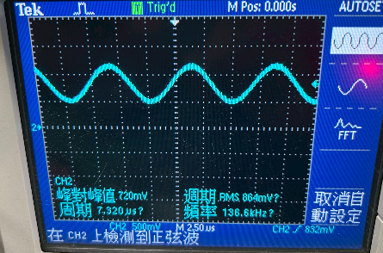

1. Low-frequency cutoff point, f‑c = 12kHz

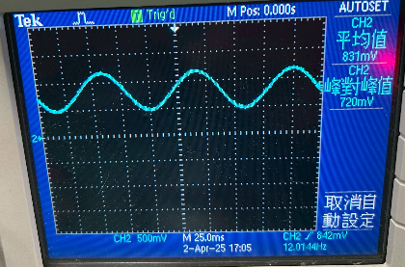

###### Find the maximum undistorted point

1. Maximum Vp-p = 2.64V

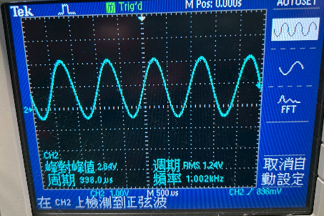

1. Output power

###### Total harmonic distortion

1. Waveform

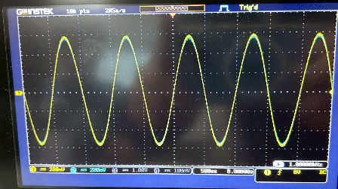

1. THD+N-ratio

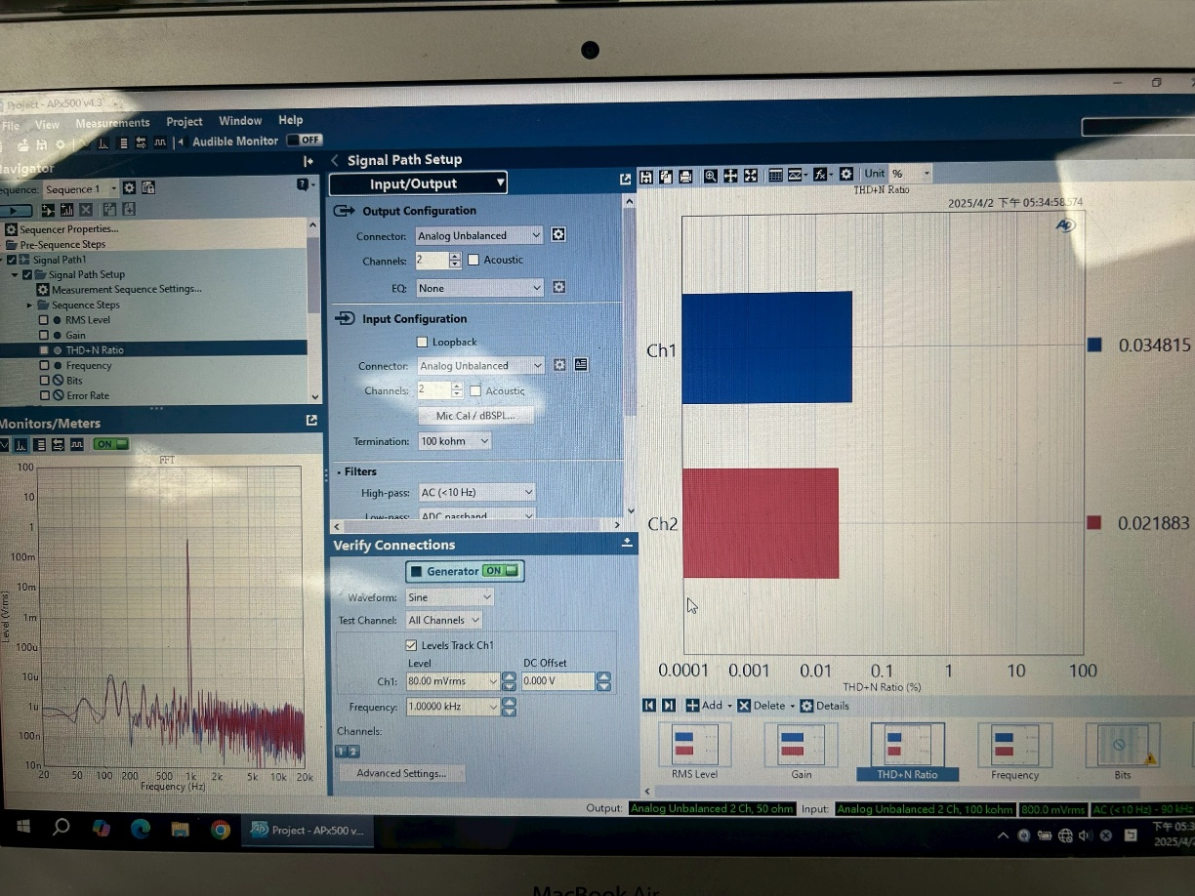

### Reflections

This Class A amplifier experiment was a valuable hands-on experience. Although we did not design the circuit diagram ourselves, every step of the process, from cleaning the board, soldering the components, to the subsequent circuit testing and parameter measurement, gave me a deeper understanding of the Class A amplifier.

During the experiment, I gained a more direct understanding of the component layout and connections on the circuit board. After completing the circuit soldering, we began testing the circuit. Using an oscilloscope and signal generator, we gradually checked the operation of the circuit and made necessary adjustments.

Next, we proceeded with parameter measurements. By measuring voltage gain, waveform, and other parameters, we noticed some differences between the actual measured results and the theoretical values. This could be due to factors in the actual circuit, such as component tolerance and noise.

Through this experiment, I gained a better understanding of the advantages and disadvantages of Class A amplifiers. Although Class A amplifiers have the advantage of high linearity, they are less efficient and consume more power.